
NAME: BISMA FATIMA
CLASS: CS A
ROLL NO: F24605036
COURSE: INFORMATION SECURITY
COURSE CODE: CS-291
LECTURER: MISS ATTIA ASHRAF

LAB 03

Lab Activities
1. Rootkit Hunter Installation: Follow the lab manual to install rkhunter in Ubuntu.
1. Update packages
Sudo apt update
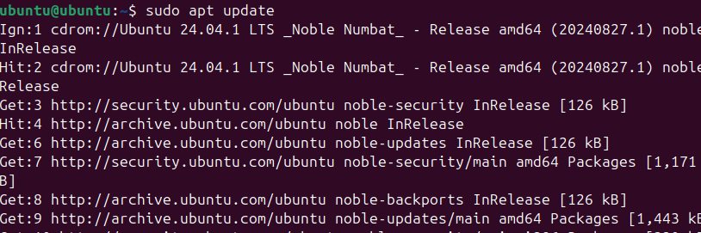

2. Install Rootkit Hunter
Sudo apt install rkhunter
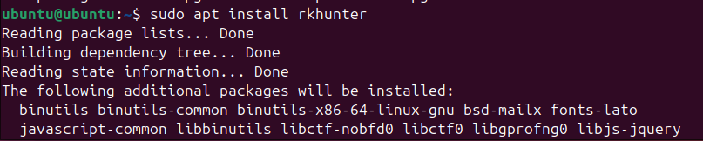

3. Postfix Configuration
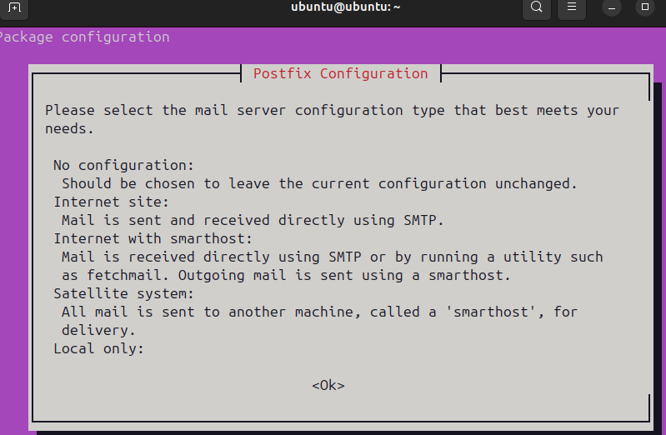
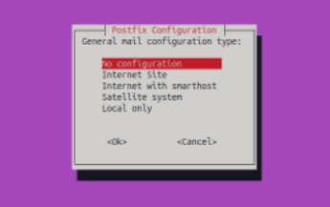

2. Run Scan: Run an initial scan following the instructions given in step 5. Investigate and document any suspicious findings.
Sudo rkhunter –check

o It will check system commands:

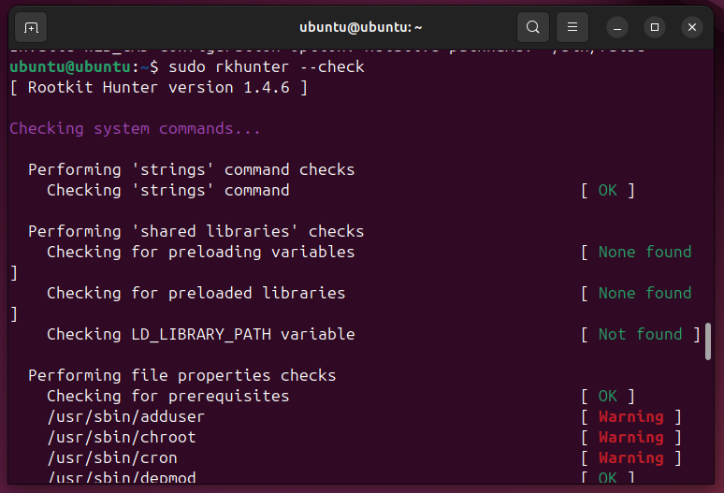
Warnings
/usr/sbin/adduser [ Warning ]
/usr/sbin/chroot [ Warning ]
/usr/sbin/cron [ Warning ]

Explanation:
🔄 Reason | Description
System Updates | If you've recently updated packages via apt, it's common for binaries like /usr/sbin/adduser, cron, etc., to change — perfectly normal.
Suspicious Modifications | If you haven't updated the system and these files changed unexpectedly, it could suggest tampering (e.g., a rootkit or malicious software replacing them).
Custom changes | Manual editing or custom recompiling of these binaries.

o Then it will check rootkits:
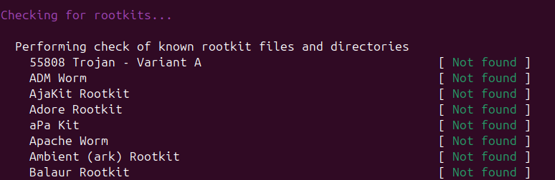
o Next up, rkhunter performs additional checks, which include:
▪ Additional rootkit checks
▪ Malware checks
▪ Linux specific checks
o Once done, press Enter.
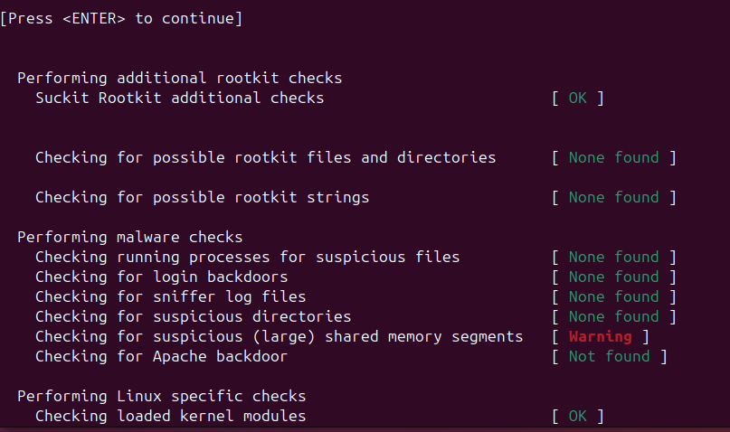
Warning
Checking for suspicious (large) shared memory segments [ Warning ]
Explanation :
comes from a rootkit or malware scanning tool like Chkrootkit or RKHunter. This specific warning indicates that the scan found one or more large shared memory segments that could be suspicious.

o The last scan checks
▪ Network
▪ Local host
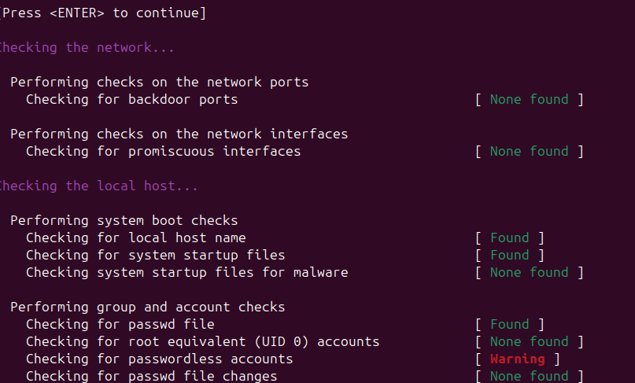
Warning
Checking for passwordless accounts [ Warning ]
Explanation :
means that the scanner found one or more user accounts on your system that can log in without a password, which can be a security risk.
SUMMARY
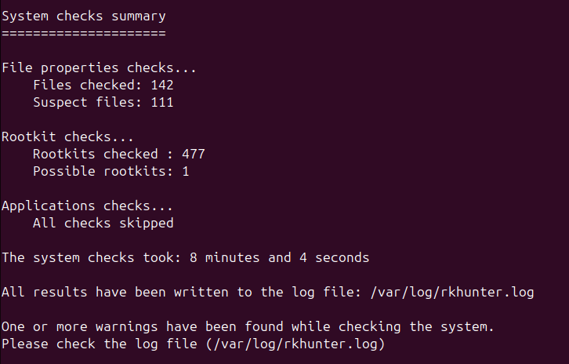

3. Logs Analysis: Examine the log file (/var/log/rkhunter.log) and identify any rootkit warnings or suspicious activities.
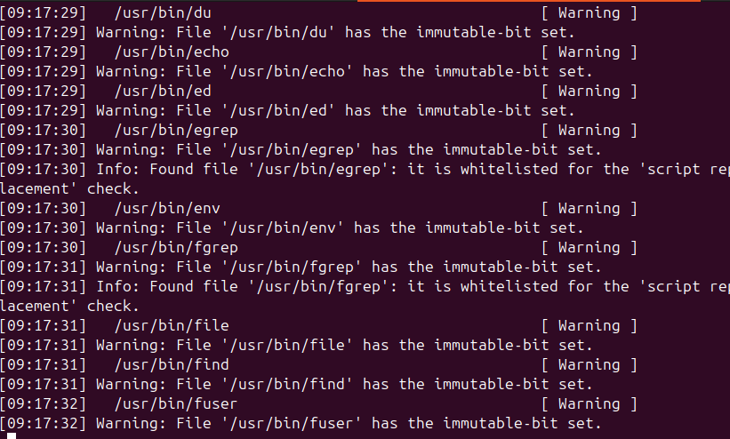

Indicator | 🧠 Meaning
Warning: The file properties have changed: | A system file may have been altered (e.g., /usr/bin/ssh)
Suspicious file found: | Hidden or unusual files (e.g., /dev/.bash_history)
Possible rootkit: | RKHunter suspects a known rootkit (e.g., Adore, Xzibit)
Unexpected file in system directory: | Files that shouldn’t be there
System checks summary | Shows total checks, suspect files, and rootkits found

Lab Submission Requirements
Write a report summarizing the findings of their RKHunter scan, including explanations of any false positives or actual threats.
Answer the following questions in the report:
1. What are the most common types of rootkits detected by RKHunter?
ANS:
1. Kernel Rootkits
- These hide deep inside the operating system’s core (the kernel).
- They can control everything and are very hard to detect.
- Example: They might change how system calls work so malicious actions look normal.
2. User-mode Rootkits
- These live in regular programs and processes.
- They often replace system tools like ls, ps, or netstat with fake versions that hide their tracks.
3. Loadable Kernel Module (LKM) Rootkits
- These are a type of kernel rootkit that loads like a driver.
- They can be added to the system while it’s running, making them flexible and dangerous.
4. Memory Rootkits
- These only live in RAM (temporary memory).
- They disappear when the system reboots, but while active, they can do serious damage.
5. Bootloader Rootkits
- These infect the system before the operating system even starts.
- They’re very stealthy and hard to remove because they run before antivirus tools can load.
6. Firmware Rootkits
- These hide in hardware like your network card or hard drive firmware.
- They survive even after reinstalling the operating system.

2. How can we distinguish between legitimate software and rootkits?
ANS:
Feature | Legitimate Software | Rootkit (Malicious)
Purpose | Helps the user or system | Hides and controls the system secretly
Visibility | Easy to find and open | Often hidden or disguised
Signature | Has a valid digital signature | May have no signature or a fake one
Behavior | Works normally and predictably | Acts strangely or hides processes
File Changes | Doesn’t change system files unexpectedly | Alters or replaces system files
Network Activity | Connects to known servers | May connect to unknown or suspicious sites
Tools to Detect | Not flagged by security tools

3. What steps would you take if RKHunter detected a potential rootkit on a production server?
ANS:
1. Don’t Restart the Server
- Rebooting might make things worse or erase clues.
2. Check If It’s Real
- Sometimes RKHunter gives false alarms.
- Look at the warning carefully and compare it with trusted sources.
3. Disconnect the Server
- Take it off the internet to stop hackers from doing more damage.
4. Save Everything
- Make a copy of the system so you don’t lose evidence.
- Write down what you find.
5. Investigate Safely
- Use clean tools (like from a USB or live CD) to look for strange files or programs.
6. Check Other Systems
- See if other computers are also affected.
7. Fix the Problem
- If it’s a real rootkit, reinstall the system from scratch.
- Change all passwords and update software.
8. Tell the Right People
- Let your team or boss know.
- Report it if needed.
9. Make It Safer
- Add security tools.
- Scan regularly to catch problems early.

